FIFA World Cup 2026 Team Dataset – Data Collection and Cleaning Report

1. Overview
This report documents the process of collecting, cleaning, and preparing the FIFA World Cup 2026 team dataset.
The dataset consists of 48 international football teams, their rankings, performance metrics, and qualification
status. Data was scraped from publicly available sources such as Wikipedia and Kaggle, then processed into both
raw and cleaned formats suitable for machine learning applications.

2. Data Sources
The following sources were used to gather data:
1. Wikipedia – FIFA Men’s World Ranking (https://en.wikipedia.org/wiki/FIFA_Men%27s_World_Ranking)
→ Provided current global FIFA rankings for each team.
2. Wikipedia – 2026 FIFA World Cup Qualification (https://en.wikipedia.org/wiki/2026_FIFA_World_Cup_qualification)
→ Listed qualified teams for the upcoming tournament.
3. Kaggle – International Football Results (https://www.kaggle.com/datasets/martj42/international-football-results-from-1872-to-2017)
→ Historical match results used to compute Win Percentage and Goal Difference.
4. Wikipedia Team Pages – For average squad age and experience.

3. Custom Web Scraper Documentation
A Python-based scraper was developed using the libraries `requests`, `BeautifulSoup`, and `pandas` to automate
data extraction from Wikipedia. The scraper collects real-time team names, FIFA rankings, and qualification
status and stores them in a CSV file. The code can be executed locally or in Google Colab.

Sample Code Snippet
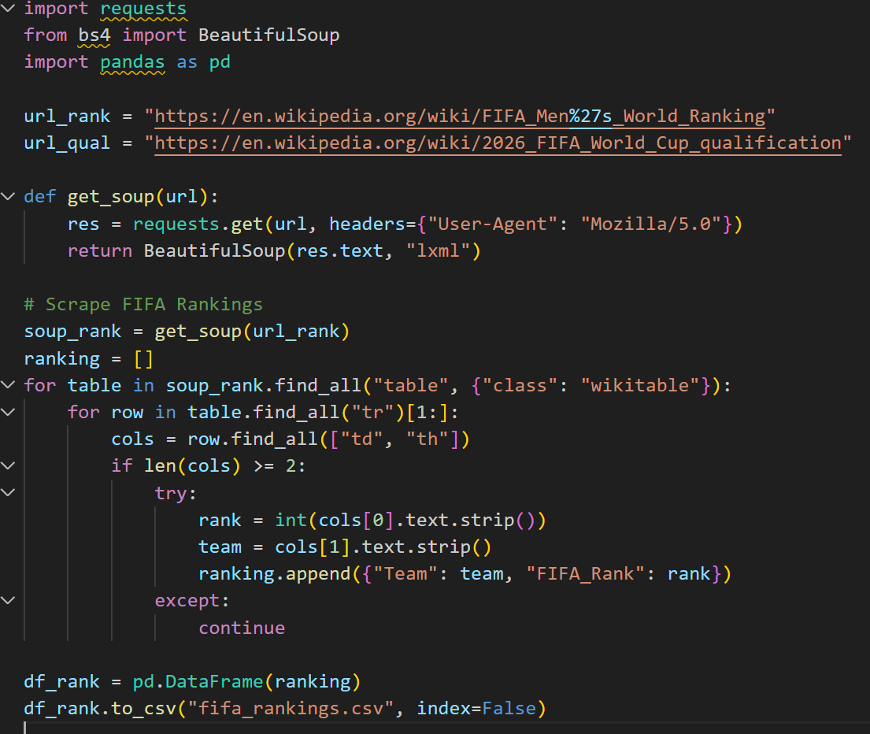
The scraper can be modified to extract additional attributes such as player age, experience, or recent
performance metrics. The use of polite scraping practices, including delays between requests and user-agent
headers, ensures compliance with website policies.

4. Data Cleaning Steps
The raw scraped data contained missing and inconsistent values due to variations in country names and
availability of historical data. The following cleaning procedures were applied:
- Filled missing FIFA ranks using median values.
- Normalized team names to match between sources.
- Replaced missing average ages with column median (default = 27 years).
- Computed WinPct (win percentage) and GoalDiff (average goal difference) from Kaggle data.
- Encoded binary features: Host (1=Host nation, 0=Otherwise), Qualified_2026 (1=Yes, 0=No).
- Exported final cleaned dataset to Excel and CSV formats.

5. Feature Rationale
Each column in the dataset serves a specific purpose for predictive modeling:
- Team: Official country/team name.
- FIFA_Rank: Indicates global performance strength.
- Avg_Age: Helps estimate maturity and experience levels.
- WinPct: Historical success rate from previous matches.
- GoalDiff: Average scoring margin; reflects offensive and defensive capability.
- Experience: Average player caps; indicator of team stability.
- Host: Binary variable (1 if host nation).
- Qualified_2026: Binary variable representing qualification status.

6. Conclusion
The dataset generated through this scraping and cleaning process serves as a comprehensive resource for analyzing
FIFA World Cup team performance. It integrates live ranking data, qualification status, and derived statistics to
enable AI/ML-driven predictions for tournament outcomes.

